**Workaround for manually deploying RPD, if RPD deployment is not working from EM.**

First of all stop all services from EM or from console.

After that, for deploying RPD, look at NQSconfig.ini file at location

/app/Oracle/Middleware/instances/instance1/bifoundation/OracleBIServerComponent/coreapplication_obis1/repository

And look for [REPOSITORY] section in that file, as shown in below snapshot.

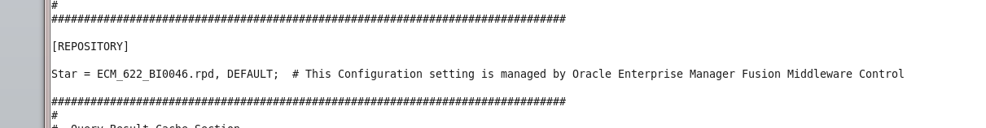

After that, rename your repository with that name as specified in the above [REPOSITORY] section and change its password to the password of that deployed rpd with the above name..

Then navigate to the repository directory at path,

/app/Oracle/Middleware/instances/instance1/config/OracleBIServerComponent/coreapplication_obis1

And copy and replace that renamed rpd with the previously deployed RPD, and start services.